The 2020 Mid-West Hottenstein Reunion, in Potosi, Wisconsin,
will be held on Sunday August 16, 2020.

Following is the postcard announcement and information about this Reunion.

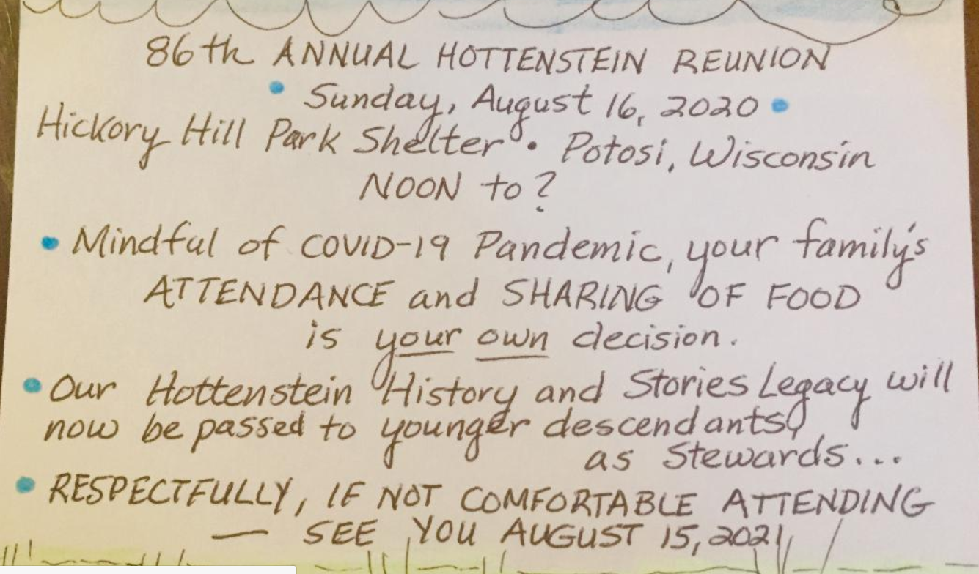

For more information or with questions, contact –

Patricia Hottenstein Moritz
3312 Magnolia Court
Bettendorf, Iowa 52722-2363

Email: mommyloon@yahoo.com
Telephone: 563-505-4429

